ORIGINATOR:
Name | Job Title | Signature | Date
Brian Cullinan | Software Developer

APPROVALS:
Name | Job Title | Signature | Date
Nancy Rizzo | Founder, CEO
Lloyd Kurth | Technology Director
Dan Miller | Manufacturing Engineer
Jan Ayres | Project Implementation Manager
Andrea Miller | Quality Assurance Director
Revision History
Revision | Revision Date | Reason for Revision/Change Request | Revised By
000 | 18-Sep-12 | Initial Release | L. Kurth  B. Cullinan

Table of Contents
1 Purpose 4
2 Scope 4
3 Definitions 4
3.1 References 4
3.2 Terms 4
4 System Architecture 4
4.1 ClearView 5
4.2 MatLab 5
4.3 MCR 5
4.4 C# Library 6
4.5 Tools 6
5 System Design 6
5.1 Setup Verification (Calibration) 6
5.2 Coefficient Analysis 6
5.3 Packages 6
5.4 User Interface 7
5.4.1 MatLab 7
5.4.1.1 Command Window 7
5.4.1.2 Current Working Directory 7
5.4.1.3 Project Window 7
5.4.1.4 Output Window 7
5.4.2 Baseline Image Set Creator 7
5.4.2.1 Input Setup 7
5.4.2.2 Output Windows 7
5.4.2.3 Sector Alignment Rings 7
5.5 Access Restrictions 7
6 Component Design 7
6.1 Setup Verification (Calibration) 7
6.1.1 CheckCalibration 7
6.1.1.1 Purpose 7
6.1.1.2 Input Variables 8
6.1.1.3 Output Variables 8
6.1.1.4 Function 8
6.1.2 BinImageNorm 8
6.1.2.1 Purpose 8
6.1.2.2 8
6.2 Baseline Image Set Creator 9
6.2.1 9
6.2.1.1 Purpose 9
6.2.1.2 Function 9
6.3 Coefficient Analysis 10
6.3.1 Computer_Factors 10
6.3.2 Im2EllAlign 10
6.3.3 FormC_NoSub 10
6.3.4 FormC 10
6.3.5 FormJS_NS 10
6.3.6 Coeff_Sectors_Orig 10
6.3.7 Coeff_Frac 10
6.3.8 Calib_JS 10
6.4 Scoring Algorithm 10
6.4.1 Coefficient Input 10
6.4.2 Mathematical Transformations 10
6.4.3 Logistic Regression 10
6.4.4 Odds Ratio Calculation 10
6.4.5 Decision Tree 10
6.4.6 Report Scores 10
7 Requirements Traceability Matrix 10

Purpose
The purpose of this document is to describe the architecture, design and implementation of algorithms used throughout the ClearView application.

Scope
The scope of this document covers the interactions between the ClearView application and the algorithms implemented in MatLab. This document covers acceptable inputs and outputs. The analysis functions performed on the inputs. And, the tools used to analyze and determined the acceptable ranges for the inputs.

Definitions
Throughout this specification document references are made to the following documents and terms.

References
SR-002.001 | EPIC Central Requirements
SS-004.001 | EPIC ClearView Synchronization Service Software Specification
MVC | Model-View-Controller on Wikipedia
REST | Representational State Transfer on Wikipedia
LLBLGen Pro | The LLBLGen Pro web site
Authorize.Net | The Authorize.Net Developer Center
jQuery | The jQuery home page
Google Maps | The Google Maps developer site
Google Translate | The Google Translate help page

Terms
Administrator | Either a Service Administrator or an Organization Administrator; see those definitions below.

System Architecture
The system architecture is detailed in the ClearView Architecture document. See reference.

ClearView
ClearView uses a series of mathematical algorithms which are implemented in MatLab (described below). Execution of these functions from ClearView, which is implemented primarily in C#, is performed through a COM interface (described below). MatLab requires a series of configuration steps to create this interface between the two applications.

MatLab
Mathworks MatLab is a mathematical analysis tool, with a processing engine. Specifically, version 2009rA is currently used with ClearView. MatLab serves as both a development environment and a redistributable executable. As a development environment, MatLab provides all the tools necessary for writing math-centric algorithms, executing, and testing all within one cohesive interface.
When the development of MatLab code shifts from development to integration with other applications the code must be “compiled” in to a DLL. This is done on demand using the compile functions within MatLab. The output from this process is a library that can be included in the ClearView project in Visual Studio. This library is called a MatLab Compiled Runtime (MCR) which is described below.

MCR
MatLab Compiled Runtime is a library generated by MatLab, based on code that is developed and compiled within the MatLab environment. This library can be used with Visual Studio projects, in our case ClearView. The MCR requires that the MatLab redistributable package be installed. This acts as a standalone package that operates MatLab functions without the need to install the entire MatLab suite. Licensing for MCR allows for this redistributable package to be installed on any computer, whereas the MatLab suite requires a user license to be used for development.
The MCR can be thought of as its own process running in memory. When it receives a request to perform calculations, it queues the calculations, executes them, and then returns the result to the requestor. This process is represented by the flow chart below:

The Component Object Model is interface that allows custom libraries to define how data structures in memory are defined. This allows C# to translate a string of characters and numbers in to bytes in memory that MatLab can understand and perform mathematical functions on.
When results are returned the ClearView the COM interface acts in reverse converting bytes of memory in to objects that ClearView can understand and ultimately save in the database for reference.

C# Library
The output from compiling MatLab code in to a library must be included in the C# project. The following section 5.1 Setup Verification (Calibration) and 5.2 Coefficient Analysis details the outputs from the two libraries created for use within ClearView. Once the library is included it is called just like any other object.
The static constructor for these libraries initializes a reference to the Component Technology File (CTF). This is basically a binary file which MatLab interprets as the algorithm code. It is very similar to Microsoft CLR or Java Byte code, however the specifications for it are closed source and is intended to protect the actual MatLab code being executed. It is not quite encryption, but it’s easy to think of it that way. The CTF file is either automatically embedded in the Library, or can be embedded in the application as a resource.

System Design
This section provides an overview of the overall system-level design. A good understanding of these core design topics is essential to a deeper understanding of the various components presented later.

Setup Verification (Calibration)
The Setup Verification process determines if an input calibration images falls within the specified range of the baseline image.

Coefficient Analysis
The coefficient analysis algorithm is responsible for taking an input energized finger image and determining specific values for each sector of the image. The details of the coefficients and sectors are described below.

EPIC Scoring Algorithm
The scoring algorithm uses coefficients and a series of mathematical transformations to reports a score between 0 and 25 for each organ component.

Packages
Image analysis package.
Parallelism package.

Tools

MatLab
The MatLab interface has a few note-worthy pieces:

Command Window

Current Working Directory

Project Window

Output Window

Visual Studio

Importing References

Access Restrictions
MatLab is not restricted in access beyond protecting intellectual property and the terms of the license. Any output from MatLab should follow the procedure defined by EG-001, Design Control Procedure.
There is currently no specific functionality that is accessible or inaccessible based on the roles defined by SS-003, ClearView Software Specification.

Component Design
The System Architecture section above provided a summary description of the system. This major section will provide design details for all the components identified by the architecture and some others that are shared.

Setup Verification (Calibration)
There are a number of components that are used and shared by other larger components these are defined first.

checkCalibration22
checkCalibration22 is an integral method of the setup verification process. This function is implemented in MatLab code. This section serves as a guide to the MatLab code; however greater details can be derived by looking at the code comments within the file.

Purpose
This function is used to verify that an input image taken using the device probe is within acceptable bounds (tested to produce expected results) of brightness, exposure, and gain settings. The algorithm compares the input image to a “baseline” image generated by averaging hundreds of perfect calibration images together. The generation of a baseline image is described in the Baseline Image Set Creator section.
The input image is compared against the baseline and standard deviation on a pixel-by-pixel basis and as a whole. These values must meet the configuration restrictions passed in as parameters along with the input image (described below).
As detailed by the Baseline Image Set Creator, images are mapped to 4 regions. An identity matrix is used to calculate passing or failing pixels for each region. These four regions are:
- Inner – the inner circle below the probe which appears mostly black.
- Outer – The region beyond the plasma which appears mostly black.
- Corona – The “fingering” section of the corona which appears to have little lightning bolts fingering out from the center.
- High Plateau – The brightest part of the image between the fingering corona and the inner ring, this is the peak of the corona.

Inputs
The checkCalibration22 function accepts parameters to perform its calculations on:
- imageBaselineSetFile – The baseline CData.mat file which is an output from Baseline Image Set Creator detailed below.
- IUTFile – A single setup verification image file location.
- sigmaRegions – indicates the flat absolute value difference a pixel can be from the baseline to indicate a failure.
- threshRegions – indicates the percent of failures within a region that would cause the overall image to fail.
- binDepth – the size of the block of pixels binned together while searching for clumps of bright pixels which detects a dirty glass electrode surface.
- sigmaMeans – The number of standard deviations away from the baseline image that would indicate a failure.
- useIm2EllitCenter – Use the same algorithm as the coefficient analysis to find the center of the image input image, otherwise use Canny method of edge detection.

Outputs
The variable names below are named after the exact usage within the .mat code file used in MatLab.
- status – this is a single digit value indicating that the image has passed or failed calibration.
- stat – Is a structured array with the following data:
- matFail – A vector with 6 elements indicating the count of failed pixels, that is failed pixels in inner, outer, corona, high plateau, failed clumps, and total failures.
- matTotal – A vector contains the total number of pixels in each region.
- percentFail – The percent of failures within each of the 6 regions.
- stdFail – Vector of 6 elements indicating the status of each tested region by comparing the percentFail of each region with the threshold value from the threadRegions input.
- meanFail – Vector with 4 elements indicating the status of each tested region computed by comparing the difference between the mean or each region and the threshold input values.
- meanDiff – Vector with 4 elements indicating the difference in the mean value of the input image and the baseline image.
- output – Stores various output information used for debugging:
- IUT – The input image returned as an output.
- currDiffImage – The difference image created by taking the input image pixels and subtracting the baseline.
- idxFailO, idxFailI, idxFailC, idxFailH – Listed as separate variables, these are the identity mapping of the failed pixels for each of the 4 regions.
- aveIntensityO, aveIntensityI, aveIntensityC, aveIntensityH, aveIntensity – The average intensity of each of the 4 regions and the overall total.
- currStddevImagebin – The input image binned using the depth specified. This is the result of the binImageNorm function described below.
- idxFailClumps – The binned image compared to the sigmaRegions for pixels too far from the baseline. This indicated the exact bin clumps in the image that failed.

Function
The setup verification process begins by capturing a new image using the calibration probe on the device or loading a previous image available to administrators.
The image is passed in to the checkCalibration22 function where each pixel is read in to a matrix the same size of the image. The “brightness” of the pixel is determined using a single dimension (R, G or B) of the three dimensional array illustrated by the matrices below:
$$\left[\begin{aligned}R=\left|\begin{matrix}R_{11} & … & R_{1n} \\ ⋮ & ⋱ & ⋮ \\ R_{m1} & … & R_{mn}\end{matrix}\right| \\ G=\left|\begin{matrix}G_{11} & … & G_{1n} \\ ⋮ & ⋱ & ⋮ \\ G_{m1} & … & G_{mn}\end{matrix}\right| \\ B=\left|\begin{matrix}B_{11} & … & B_{1n} \\ ⋮ & ⋱ & ⋮ \\ B_{m1} & … & B_{mn}\end{matrix}\right|\end{aligned}\right]$$
Since the image is grayscale, R, G, B should be exactly the same.
The baseline data file is loaded for later use.
The first task is to center the input image so that it may accurately be compared to the baseline image. Canny edge detection is used to find the inner edge, the widest and smallest points are then measured and the center point of the ellipses is calculated. The image is transposed to the absolute center of the baseline image. The Coefficient Analysis algorithm for finding the center can also be used when the last flag (useIm2EllitCenter) is set to true or 1.
Each pixel in the image is compared to the baseline average image multiplied by the specified number of standard deviations (default is 2). When a pixel falls outside 2 standard deviations it is counted as a failure. Every failure is summed for each region, and the overall total failures.
The mean difference is calculated by subtracting the baseline average and the input image. The absolute value is taken for each pixel and compared to the input sigmaMeans to determine the number of standard deviations away from the average region wide that the input image can be to indicate a failure.
The image is then binned using the binDepth, in order to find clumps of unusual (not matching the average) pixels. This process uses standard square binning, when depth is set to 4, the image is split in to a grid of 4x4 pixels in each block. The 16 pixels in each block are averaged together to create 1 value. If any of those values are outside the number of standard deviations defined in the sigmaRegions input, the clump is counted as a failure.
Finally, the results are tallied and returned to ClearView in a COM object. The Matlab library reinterprets the COM object as .Net data types and they are stored in the database for later reference.

BinImageNorm
BinImageNorm is a standard binning algorithm that takes an input image, and a binDepth. An image with a binDepth of 4 is divided in to 4x4 blocks of pixels. All 16 pixels are averaged together to create a single value per block of pixels. The result is a matrix that is the size of the input image divided by the binDepth.

Baseline Image Set Creator
Baseline Image Set Creator is a tool used to blend “perfect” calibration images in to one average image. The image is then analyzed pixel-by-pixel and the standard deviation, median, and range are determined per-pixel. This tool allows us to determine in new input images fit within acceptable range of the determined “perfect” image. The output of this tool is a simple .mat file called CDATA.mat. This file contains all the variables necessary to filter out input calibration images as described below.

Purpose
The purpose of this tool is to provide an easy to use interface to manipulating a large matrix that describes a 320 x 240 pixel bitmap. The tool loads a set of any number of images and finds the average, standard deviation, and aggregate values for the entire set. It optionally displays a tool for moving the region definitions which translate in to 4 identity matrices stored in the CData.mat file. These processes can be done manually by hand but it would take a huge amount of time.

Inputs
“Directory of Training Data” – The directory of which to load setup verification images to be used in blending calculations.
Automatic segmentation (option) – Automatically distributes the regions and displays an edit dialog for creating region identities.

Outputs
Image Baselines Set File – Average and standard deviation information for each pixel, identity matrices describing each region, and overall region averages and standard deviations.

Function
The primary display is a dialog which allows the directory of images to be selected and a checkbox for automatically selecting the 4 regions:
- Inner – the inner circle below the probe which appears mostly black.
- Outer – The region beyond the plasma which appears mostly black.
- Corona – The “fingering” section of the corona which appears to have little lightning bolts fingering out from the center.
- High Plateau – The brightest part of the image between the fingering corona and the inner ring, this is the peak of the corona.

The number of setup verification images to be loaded is displayed.
The status of what calculation or aggregate data is being generated is displayed at the bottom of the dialog.

Input Window
The main display for loading calibration images is drafted below:
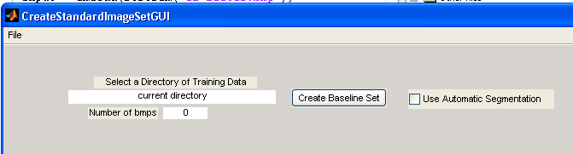
The File menu can be selected to choose a specific directory or exit the dialog:
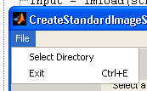
One the directory full of images to blend, the user selects “Create Baseline Set”. The images are processed, the status it updated with each step along the way, and output windows are shown.

Output Windows
Various outputs are displayed as the images are processed in order to view the resulting average and standard deviation values. This list is not comprehensive as many windows are repetitive information but segmented for each region.
When the calculations are complete the resulting average image and standard deviations are displayed:
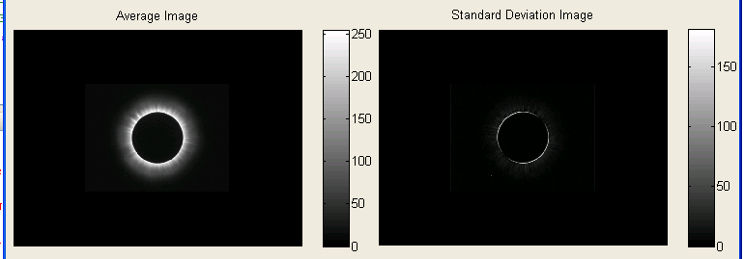
This is the average image constructed from averaging each individual pixel from each of the input images.
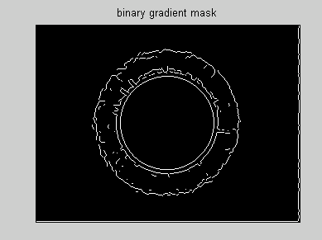
This window displays the lines between each region with the edges highlighted.
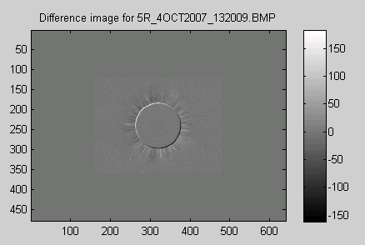
One of the images from the input set is subtracted from the average image.
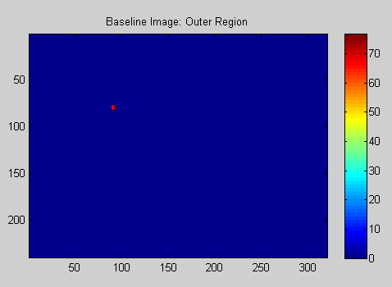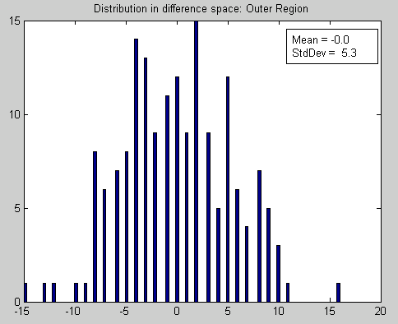
Intensity distribution for each region is shown.

Region Alignment
If automatic segmentation is left unchecked, the user is presented with a dialog for adjusting the region layout.
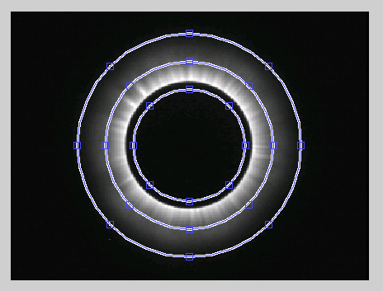
Each point can be selected and moved to generate an identity matrix for each region. Here is an example of the output from the process for the inner region:
$$Inner= \left[\begin{matrix}0 & 0 & 0 & 0 & 0 & 0 \\ 0 & 0 & 1 & 1 & 0 & 0 \\ 0 & 1 & 1 & 1 & 1 & 0 \\ 0 & 1 & 1 & 1 & 1 & 0 \\ 0 & 0 & 1 & 1 & 0 & 0 \\ 0 & 0 & 0 & 0 & 0 & 0\end{matrix}\right]$$

CData.mat Format
The final output of the baseline image set creator is a Matlab serialized binary file. This file is renamed to CData.mat to be loaded by ClearView.
idxRegionsL – Contains the four region identity matrices.
imageBaselineSet – Contains the baseline image information split in to the following name-value pairs:
averageImageL – The input images averaged together per pixel.
stderrImageL – The standard deviation of the input images per pixel.
meanMeanBase – A total mean of every pixel in the region.
stdMeanBase – The standard deviation of all pixels in a region across all input images.

Coefficient Analysis

Compute_factors
Compute_factors acts as a wrapper around all other coefficient algorithm functionality. It is the primary entry point used by ClearView to evaluate coefficients.

Purpose
The purpose of compute_factors is to perform some preliminary tasks on the inputs and to call the functions described below in a meaningful order.

Inputs
filename1 – The path of the energized image to be analyzed.
filename2 – The path of the finger image to be used in image alignment.
Mode – The part of the algorithm to execute described below.
calib_path – The path to the calibration images and the output.
im_angle – The angle of the energized image properly aligned.
Midpoint – The center of the energized image after proper alignment.
Noiselevel – The predetermined noise level found by the ClearView algorithm.

Outputs
ClearView Scan Coefficient
Average Intensity
AI1
AI2
AI3
AI4
Break
Entropy
Fractal
Form
Form1_1
Form1_2
Form1_3
Form1_4
Form 2
Form 2 Prime
NS Integer
Normalized Area
Ring Intensity
Ring Thickness
Sector Area

Function

Im2EllAlign

FormC_NoSub

FormC

FormJS_NS

Coeff_Sectors_Orig

Coeff_Frac

Calib_JS

Scoring Algorithm

Coefficient Input

Mathematical Transformations

Logistic Regression

Odds Ratio Calculation

Decision Tree

Report Scores

Requirements Traceability Matrix
This section contains a matrix that cross references each requirement to the sections of this specification that describe how the requirement is met.
Requirement | Requirement Summary | Section | Section Title
4.1.1.1 | Organization types | 6.2.1 | Organization

